Acceptance Test

ID – 04

1. Start a new game with the easiest difficulty

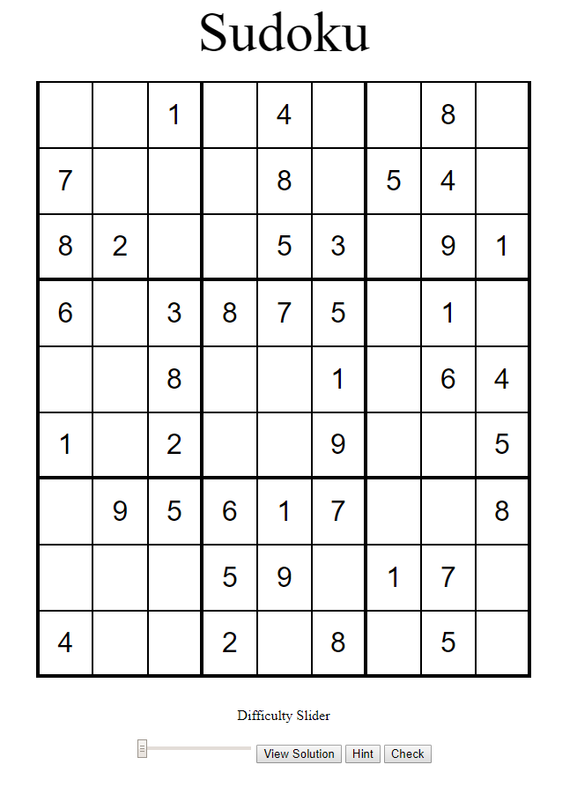

1. Input values to puzzle solver

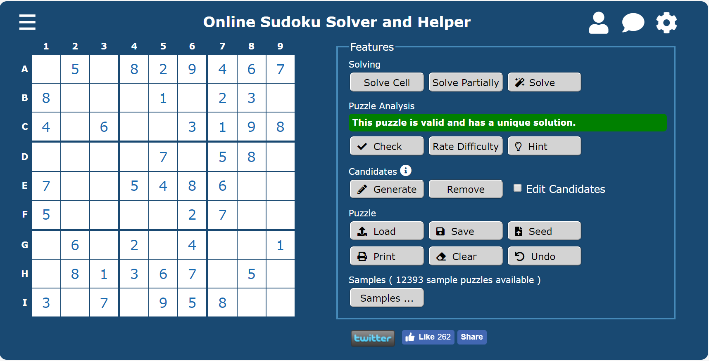

1. Match solver puzzle with puzzle solution

